Sudoku Solver
Design Document
By:
Pooya Samizadeh-Yazd
&
Kyle Smyth
for ENSE 350
Sudoku Solver Project
Introduction/Overview:
According to Wikipedia, Sudoku is a logic-based, combinatorial number-placement puzzle. The objective is to fill a 9×9 grid with digits so that each column, each row, and each of the nine 3×3 sub-grids that compose the grid (also called "boxes", "blocks", "regions", or "sub-squares") contains all of the digits from 1 to 9. The puzzle setter provides a partially completed grid, which typically has a unique solution. Completed puzzles are always a type of Latin square (A Latin square is an n × n table filled with n different symbols in such a way that each symbol occurs exactly once in each row and exactly once in each column) with an additional constraint on the contents of individual regions.
Problem Definition:
The program will be divided into User Interface (UI) and the Core Engine (CE).
The User Interface: It will basically show the status of the puzzle in text format. At the beginning of the game, the program prompts the user for entering some initial numbers into the puzzle so the program can solve based on it. The coordinates are mapped as below:
1
2 |  |  |  |  |  |  |  | 1
3
4
5 |  |  | 9
6
7
8
9
 | 1 | 2 | 3 | 4 | 5 | 6 | 7 | 8 | 9
The user will have the option to enter in a Sudoku board and click a button to have it solved via a graphic user interface.
There will be also an option for importing a test case from a text file. This can make the testing process faster. This function does not work with the GUI anymore.
After initialization, the UI will not change anything else, other than the values in the table, and it will be only called by the core engine to display the results.
There will be 3-5 buttons in the GUI. There will be a Solve, Reset and Load Example button. The Solve button will initiate a call to the solve method based on the input puzzle, the reset button will clear the board and the load example buttons will load up an example puzzle.
Because the program is designed to receive user input, there will need to be validations to ensure that the data entered by the user is valid. If there are any errors because of the input or if the puzzle is too difficult for the solver, an error message will be displayed.

The Core Engine
The solver will be able to solve easy level and some medium level puzzles with the logic algorithm, but it will be able to solve any puzzle with the brute force algorithm.
The Program:
We will be using three classes:
- Node class: Which stores a LinkedList of possibilities, the value of the node and whether it is permanent or not.
- Grid class: Which is a LinkedList that stores 81 Nodes in row major order. It contains member functions that solve the puzzle such as:
- UpdatePosibilities: Removes possibilities from the node class that the algorithm determines to be impossible.
- CheckGrid, CheckRow, CheckColumn: Checks to see if a value exists in the current grid, row or column
- SolveRecursively: Recursively solves the puzzle.
- SolveBruteForce: Uses backtracking to brute force the puzzle.

- Sudoku class: It contains all the methods for the graphic user interface such as:
- DisplayGrid: Outputs the puzzle.
- InitiateGrid: Which inserts the initial values that have been read from the file or keyboard.
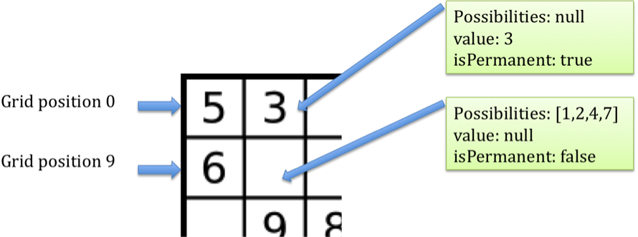
Figure 1: Data structure diagram
The Algorithms
The brute-force solver is able to tackle almost any Sudoku board, however the results could take between 30 seconds and 30 minutes because of the vast amount of permutations of a 9x9 grid. We will be using a logic-based solution, similar to how a human would solve this puzzle at the first stage then if needed, the program will invoke the brute force method to finish off the puzzle.
The algorithm starts by initiating the grid class with 81 nodes. Input is taken from the keyboard or from a file and placed into the value data members in each node within the grid. These values are considered permanent values and cannot be changed so the Boolean data member isPermanent will be set to true. Once all of the initial values are in the grid, the recursive solving method will be called. This recursive method calls a method named Update, which scans the 3x3 grid, row and column that a value is in, and removes values in the possibilities linked list for which they are no longer possibilities. Then it determines any permanent values by looking for nodes that have only one possibility. This process repeats until the puzzle is solved or cannot be solved anymore.
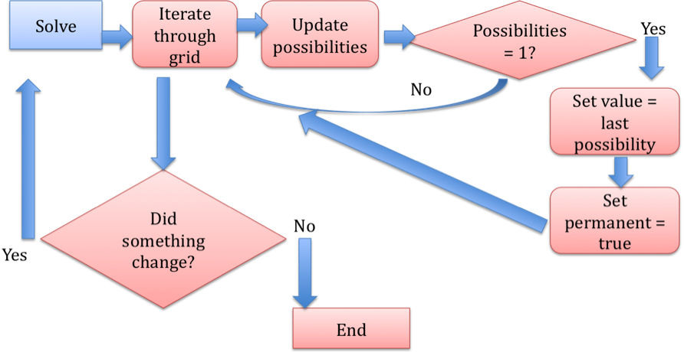
Figure 2: Logic algorithm flow chart
The brute force method first calls a method to collect the index's for all of the empty cells. It first tries to place the value 1 in the first empty cell, then it calls the three boolean check methods rowConsistent, colConsistent, gridConsistent. These boolean check methods check to see if it is a valid number in the position, if it is not then it increments that value until it is valid. Once a valid move is established the index is incremented, moving to the next empty cell and the same process is done here. If it is determined that there are no possible values for this second cell, it goes back to the previous cell and begins to increment that. The algorithm is repeated until the allowed value in the 81st cell is discovered

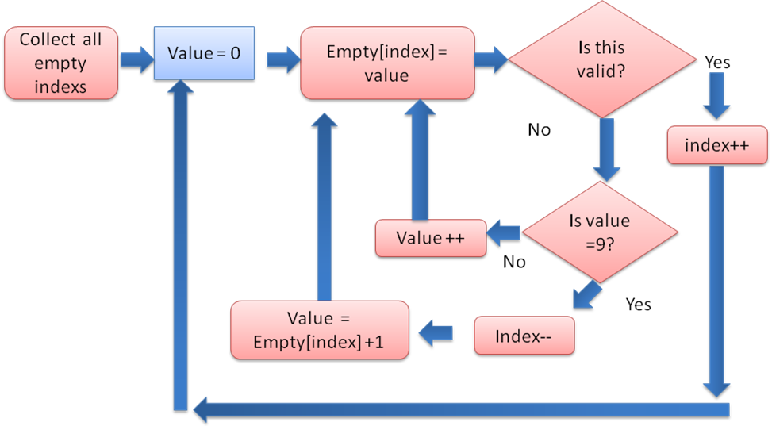
Figure 3: Brute-force algorithm flow chart

Responsibilities:
Kyle and Pooya will both work on the User Interface and Core Engine. The whole program will be done in Java and we will both work on documentation and presentation. The coding, integration and testing will be done by the first week of April and the documentation and presentation will be done during April. We will be using the provided version control so our progress can be visible to the lab administrator, course TA and the professor.

